module 'cv2' has no attribute 'SIFT'

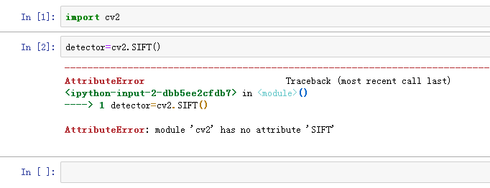

试着解决 安装opencv-contrib-python
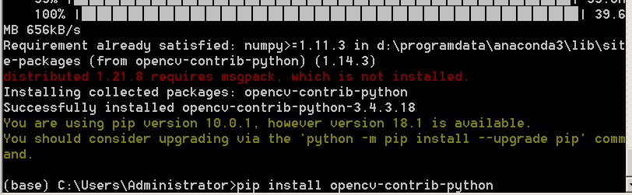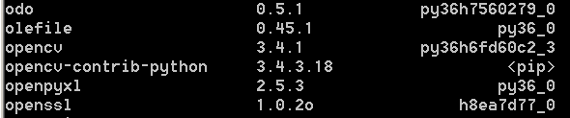
安装后，问题依旧！！

参考：
https://www.cnblogs.com/Allen-rg/p/9667926.html
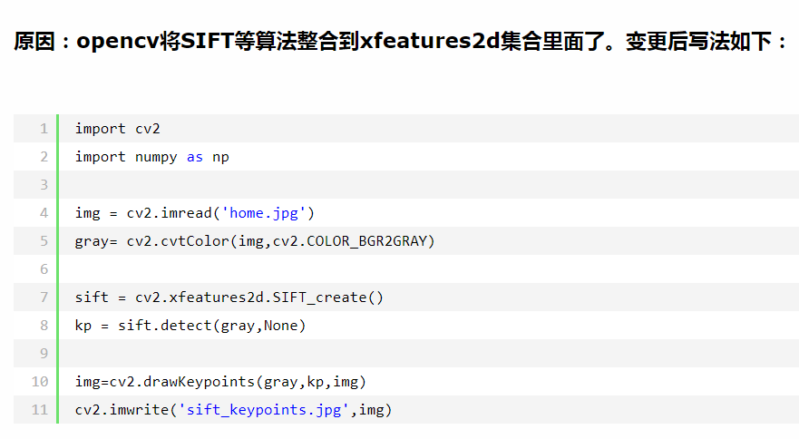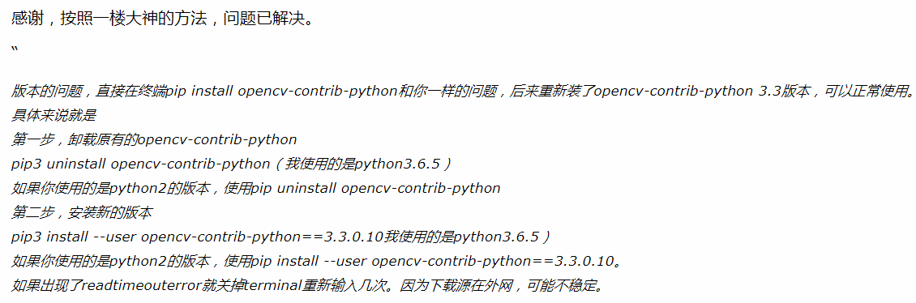

我的解决：
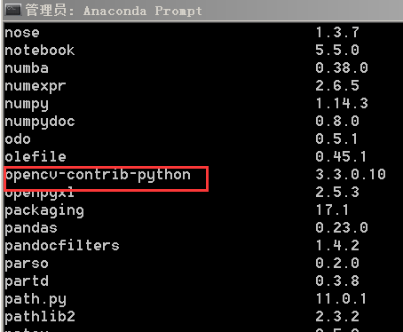
测试：
参考1：https://blog.csdn.net/u013837209/article/details/77411564
import cv2

img = cv2.imread('test3.jpg')
gray= cv2.cvtColor(img,cv2.COLOR_BGR2GRAY)
sift = cv2.xfeatures2d.SIFT_create()
kp = sift.detect(gray,None)
img=cv2.drawKeypoints(gray,kp,img)
cv2.imwrite('sift_keypoints.jpg',img)
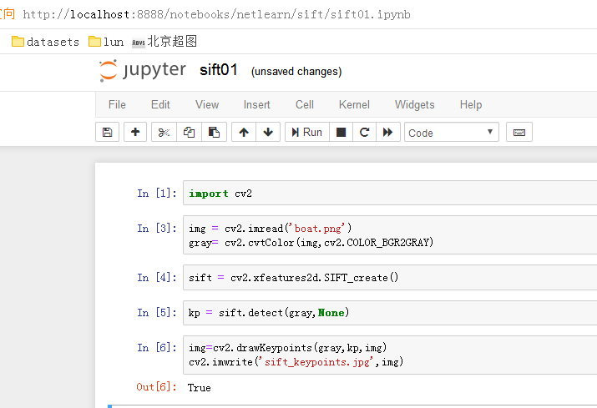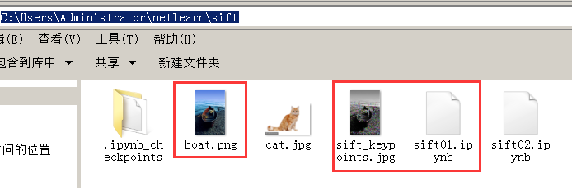

参考2：https://blog.csdn.net/u011501388/article/details/78081567

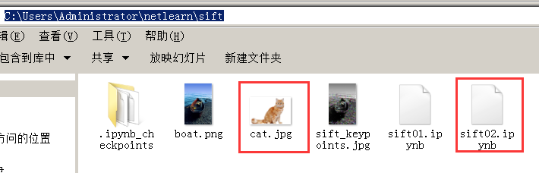
import cv2
img = cv2.imread('cat.jpg')
gray = cv2.cvtColor(img, cv2.COLOR_BGR2GRAY)
surf = cv2.xfeatures2d.SURF_create()
kp = surf.detect(gray, None)
img = cv2.drawKeypoints(gray, kp, img)
cv2.imshow("img", img)
k = cv2.waitKey(0)
if k & 0xff == 27:
cv2.destroyAllWindows()

